#DNS Tunneling

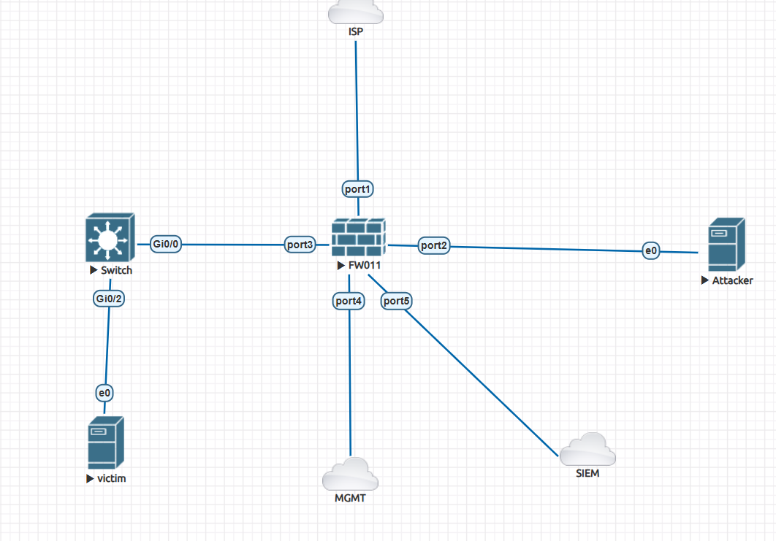

# Firewall Policy
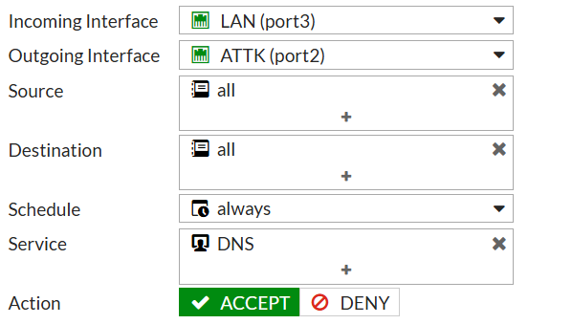

#server

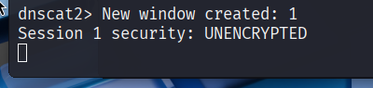

#client

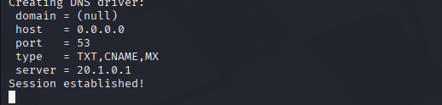

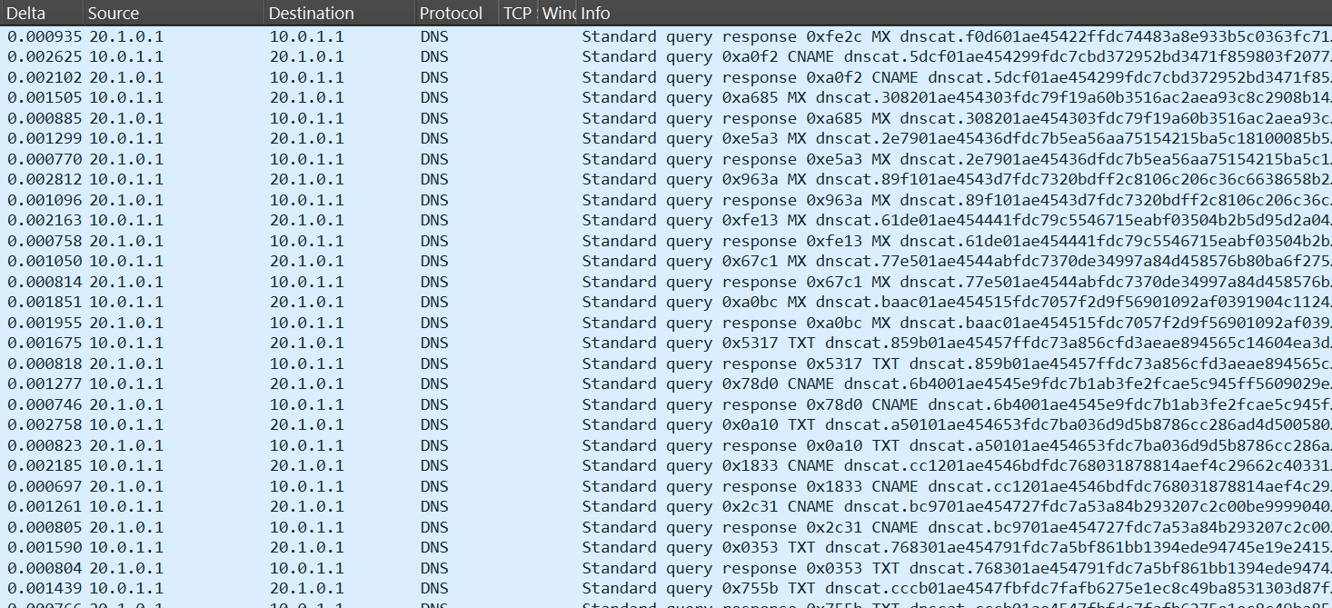

#https://attack.mitre.org/techniques/T1048/
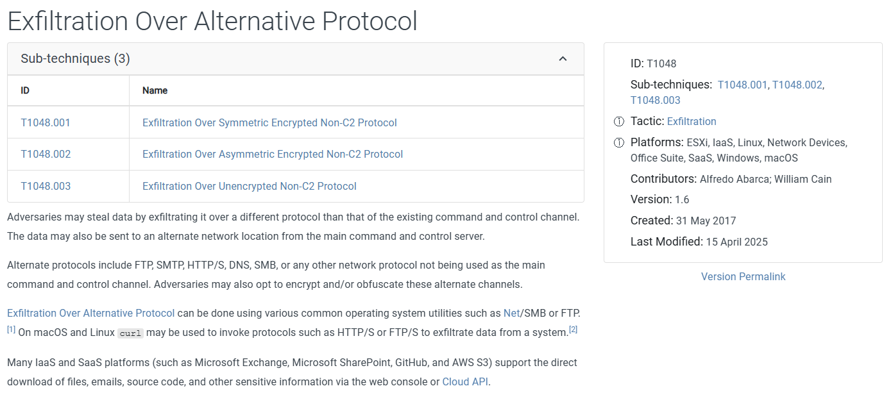

#https://unit42.paloaltonetworks.com/dns-tunneling-how-dns-can-be-abused-by-malicious-actors/
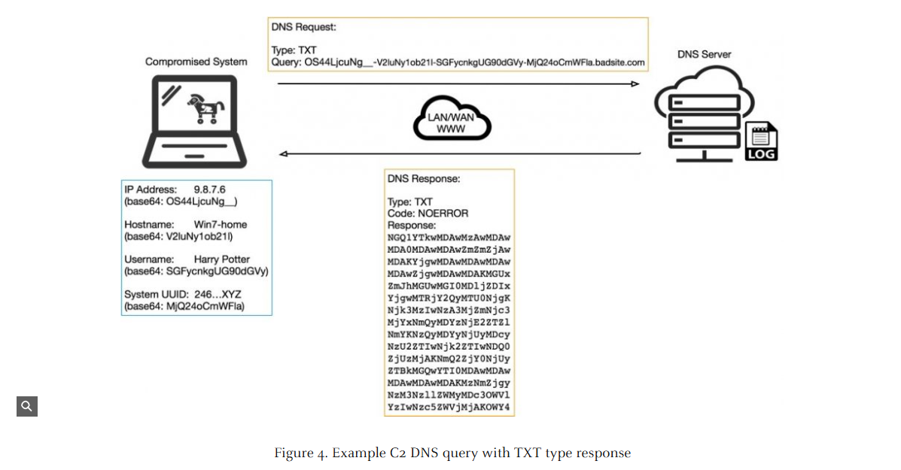

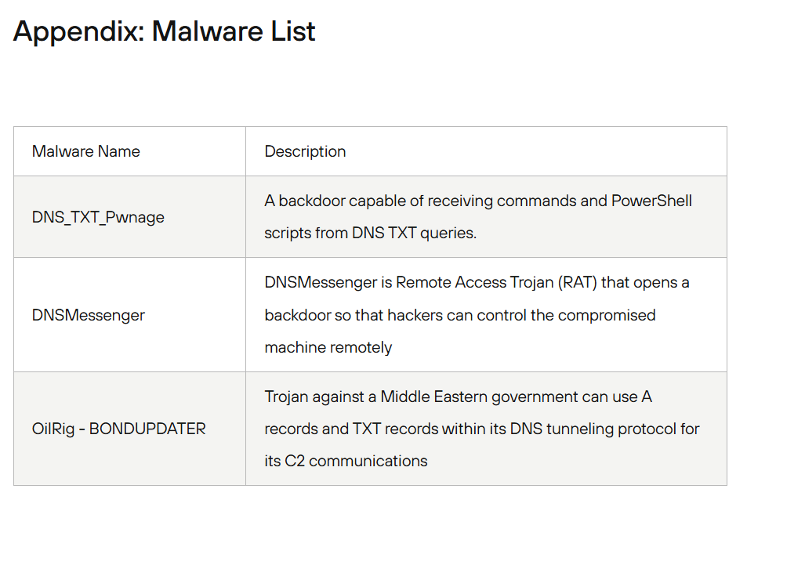

# How to analyze DNS tunneling

1 Observe unusual patterns
- Repetitive subdomains: Each query is a long, random-looking subdomain
- Multiple record types used: MX, TXT, CNAME — typical for tunnels trying to carry data.
Encoded payloads in labels: Labels like 45422ffdc74483a8e933b5c0363fc71 are not human-readable, high-entropy, likely base32/base64.

2 Key Indicators to Check

dns.qry.name.len > 50 # Long domain names
dns.flags.response == 0 # DNS queries only
dns contains "txt" # TXT record queries
dns.qry.type == 16 # TXT records
dns.qry.type == 10 # NULL records

3 Use Wireshark statistics for pattern detection
- Statistics → Protocol Hierarchy
  - Check percentage of DNS traffic that is TXT/CNAME/MX — unusually high TXT usage is suspicious.
- Statistics → DNS
  - Click “Queries” → see the most queried domains. A single domain with many unique, random subdomains is a classic tunnel indicator.
- Statistics → Conversations / Endpoints
  - Group by IP → check which hosts are making the most DNS queries. High volume from a single host is a red flag.

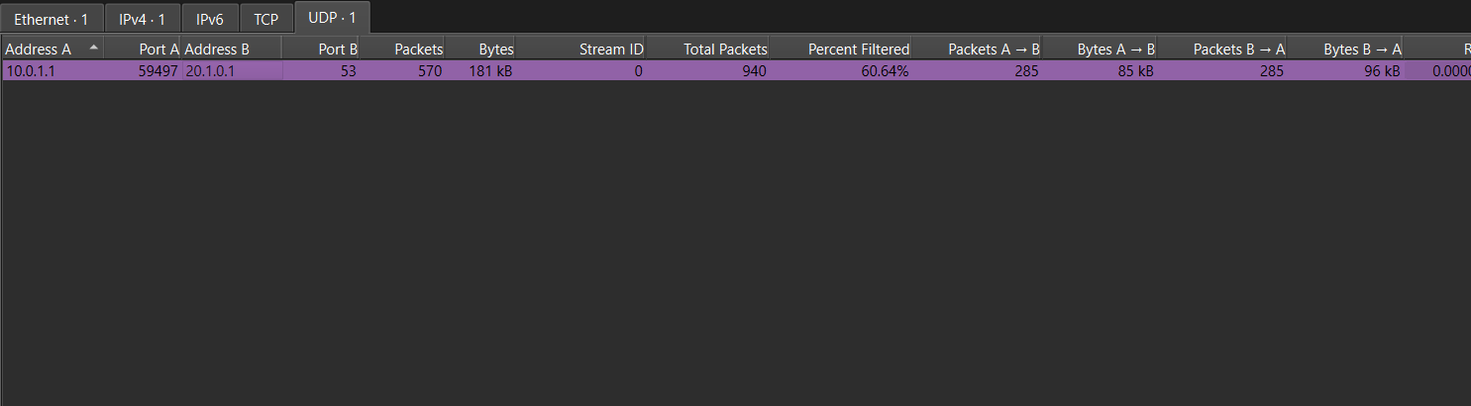

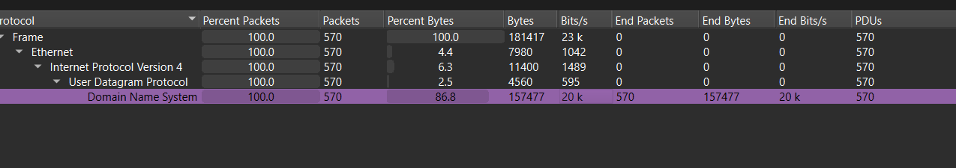

4 Manual inspection for tunneling indicators
- Look for high-entropy QNAMEs:
  - Labels like 45422ffdc74483a8e933b5c0363fc71 are not dictionary words.
- Multiple unique subdomains for one root domain:
- Query timing / frequency:
  - Check Delta column (time between packets). Regular, small intervals suggest automated tunneling.

